Students’ Initiatives / Creativity, Activity, Service (CAS)
Responsibility of the Students with New Initiatives

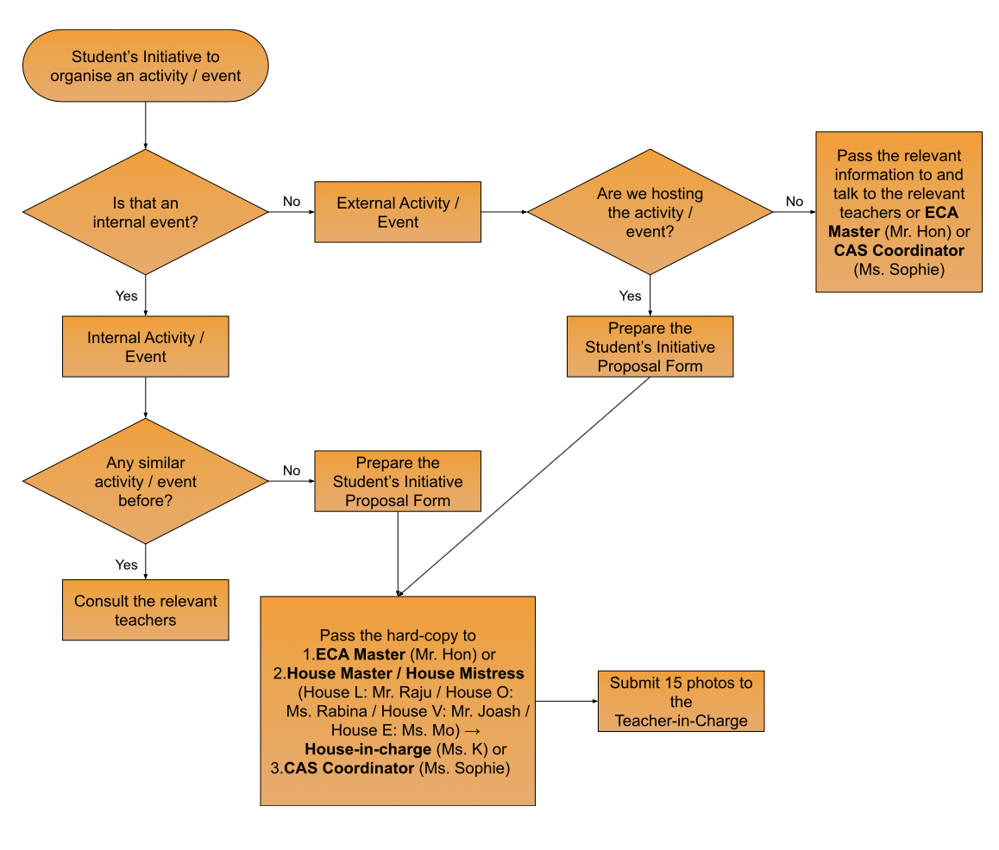
Appendix 1
Delia Memorial School (Glee Path)

Student’s Initiative Proposal Form
GENERAL INFORMATION
Club/Team (if applicable):
Teacher(s)-in-charge / Teacher Advisor (if applicable):
Date/Time/Duration:
Venue:
Target Students / Teachers:
Partnering Organization (if applicable):
Name of the Activity / Event:
DESCRIPTIONS OF THE ACTIVITY / EVENT
Objectives:
Details of the activity/event:
Promotion Strategies (pls Pthe appropriate box(es)):
- Posters in School TVs
- Posters and Captions in School Social Media
- Announcement through PA System
- Hanging Banners
- Promotion during 7:30am - 8:00am at School Entrance
- Others (please specify):

Budget (List of Items):
Item | Unit Price (HK$) | No. of Items | Sub-Total (HK$)
Example: Basketballs | HK$200 | 5 | HK$1,000
 |  | Grand-Total (HK$):

Evaluation Method(s) for the Activity / Event (pls Pthe appropriate box(es)):
- Reflections
- Questionnaires to Participants
- Others (please specify):
Proposed by:
Date of Submission:
Signature of Teacher(s)-in-charge / Teacher Advisor (if applicable):
Approved by: | (ECA Master / House-in-Charge / Head of SA / Principal)
Approval Date:

Points-to-Note:
- Your completed proposal should pass to one of the following teachers at least one month in advance of the activity / event commences. If not, you may not be authorised to organise it.
    - ECA Master (Mr. Hon) or
    - House Master / House Mistress (House L: Mr. Raju / House O: Ms. Rabina / House V: Mr. Joash / House E: Ms. Mo) → House-in-charge (Ms. K) or
    - CAS Coordinator (Ms. Sophie)
- DeliaGP has the final decision on any dispute.

